Recipes
Smokey Island Salad

Aioli
3 tbsp brown bread crumbs
1 tbsp wine vinegar
3 cloves garlic
1/2 tsp salt
3 egg yolks (pasteurized yolk will work)
300ml olive oil

Smash bread, vinegar, garlic, salt and yolks in Mexican stone (mortar) or blend in food processer.
Slowly add oil until thick.

100 gm sashimi grade tuna, large dice
100 gm fresh cooked shrimp
A good pinch of course sea salt (or kosher)

1 tbsp red onion small dice
Aioli (use as much as needed to hold everything together)
1/4 cup crisp salad leaves

Wok smoke the tuna, hot smoke until cooked, no need to smoke shrimp there will be enough smoke resin from tuna.
Chill tuna.
Mix everything except the salad together.
Don’t over stir just gently fold everything together until incorporated.
Place salad on a plate and top with tuna salad. Serve

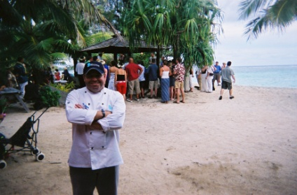

Recipes
Braised Hawaiian Pork Shoulder

Rub (best rubbed night before)
1 tablespoon brown sugar
1 teaspoon ground cumin
1 teaspoon ground coriander
1 teaspoon freshly cracked black pepper
1 teaspoon kosher salt

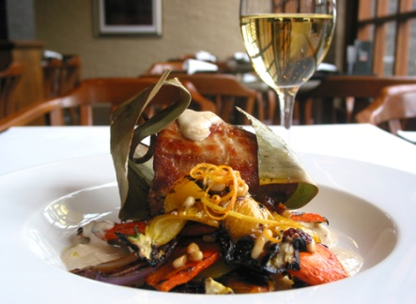
1 ½ kg pork shoulder or pork butt cut into 200 gm pieces
Banana leaf
Twine to tie

1 tablespoon olive oil
1 onion, chopped
1 carrots, chopped
4 stalks celery, chopped
1 (3-inch) piece ginger, sliced
4 cloves garlic, minced
1 cup fresh pineapple chopped
2 cups coconut cream or milk

Instructions

Preheat the oven to 180 degrees C.
In a small bowl, combine the brown sugar, cumin, coriander and black pepper. Rub pork with the spice mixture. Rest covered in chiller overnight.

In a large Dutch oven over medium high heat add olive oil and pork. Brown on all sides and remove.
Let cool and wrap in banana leaf. (Flash leaf over open flame to sterilize and soften)

Add a little more olive oil and add the onions and cook 6-8 minutes or until lightly browned. Add carrots, celery, ginger, garlic and sauté for 3 minutes. Add pineapple and coconut milk and return the pork to the pot and bring to a boil. Cover put the pot into the oven to braise until the pork is fork tender, about for 2 hours.

Gently lift pork from braising liquid. Taste and season and strain liquid.
Serve by opening banana leaf at top and pour in braising liquid.

Recipes

Coconut Rice

2 cups jasmine rice, well rinsed
1 cups cold water
2 can coconut cream 400 ml
3cm piece ginger, grated
S&P

Method

Place all ingredients in a large saucepan over high heat. Bring to the boil, stirring occasionally. Reduce heat to low. Simmer, covered, for 10 minutes. Remove from heat. Stand, covered, for 10 minutes. Discard ginger. Serve.

Island Panna Cotta

1 Tahitian vanilla pod
650 ml cream
50 gm castor sugar
2 tbsp Pacific bean coffee or espresso
6 gelatine leaves (=14 gram gelatine powder)

200 gm melting chocolate

Method

Split vanilla pod and place in a pot with the cream, sugar and coffee
Bring to a boil and add softened gelatine, remove from heat, strain thru fine sieve.
Cool over ice until it starts to set.
Pour into moulds and set in chiller.

Gently melt chocolate, pour onto a plastic wrap lined baking sheet, chill until hard.
Break abstract pieces for garnish. Serve with panna cotta.

Oven Temp Table
Gas mark Fahrenheit Celsius Verbal
n/a 150° 66° Drying
n/a 158° 70° Drying
n/a 175° 79° Drying
n/a 176° 80° Drying
n/a 194° 90° Drying
1/4 200° 93° Very Slow/Very Low
1/4 212° 100° Very Slow/Very Low
1/4 225° 107° Very Slow/Very Low
1/4 230° 110° Very Slow/Very Low
1/2 248° 120° Very Slow/Very Low
1/2 250° 121° Very Slow/Very Low
1/2 266° 130° Very Slow/Very Low
1 275° 135° Slow/Low
1 284° 140° Slow/Low
2 300° 149° Slow/Low
2 302° 150° Slow/Low
3 320° 160° Moderately Slow/Warm
3 325° 163° Moderately Slow/Warm
3 338° 170° Moderately Slow/Warm
4 350° 177° Moderate/Medium
4 356° 180° Moderate/Medium
5 374° 190° Moderate/Moderately Hot
5 375° 191° Moderate/Moderately Hot
6 392° 200° Moderately Hot
6 400° 204° Moderately Hot
7 425° 218° Hot
7 428° 220° Hot
8 446° 230° Hot/Very Hot
8 450° 232° Hot/Very Hot
9 464° 240° Very Hot
9 475° 246° Very Hot
9 482° 250° Very Hot
10 500° 260° Extremely Hot
n/a 518° 270° Extremely Hot
n/a 525° 274° Extremely Hot

